**EXPERIMENT - 1**

**AIM:** To demonstrate Booth’s Algorithm for multiplication of 2 signed binary numbers.

**Submission Sheet**

| **SAP ID** | **Name of Student** | **Date of Experiment** | **Date of Submission** | **Remarks** |
| --- | --- | --- | --- | --- |
| **60004190057** | **Junaid Girkar** | **01-10-2021** | **01-10-2021** |  |

**THEORY**:

Booth algorithm gives a procedure for multiplying binary integers in signed 2’s complement representation in an efficient way, i.e., less number of additions/subtractions required. It operates on the fact that strings of 0’s in the multiplier require no addition but just shifting and a string of 1’s in the multiplier from bit weight 2^k to weight 2^m can be treated as 2^(k+1 ) to 2^m.

Booth's algorithm can be implemented by repeatedly adding (with ordinary unsigned binary addition) one of two predetermined values *A* and *S* to a product *P*, then performing a rightward arithmetic shift on *P*. Let **m** and **r** be the multiplicand and multiplier, respectively; and let *x* and *y* represent the number of bits in **m** and **r**.

1. Determine the values of *A* and *S*, and the initial value of *P*. All of these numbers should have a length equal to (*x* + *y* + 1).
   1. A: Fill the most significant (leftmost) bits with the value of **m**. Fill the remaining (*y* + 1) bits with zeros.
   2. S: Fill the most significant bits with the value of (−**m**) in two's complement notation. Fill the remaining (*y* + 1) bits with zeros.
   3. P: Fill the most significant *x* bits with zeros. To the right of this, append the value of **r**. Fill the least significant (rightmost) bit with a zero.
2. Determine the two least significant (rightmost) bits of *P*.
   1. If they are 01, find the value of *P* + *A*. Ignore any overflow.
   2. If they are 10, find the value of *P* + *S*. Ignore any overflow.
   3. If they are 00, do nothing. Use *P* directly in the next step.
   4. If they are 11, do nothing. Use *P* directly in the next step.
3. Arithmetically shift the value obtained in the 2nd step by a single place to the right. Let *P* now equal this new value.
4. Repeat steps 2 and 3 until they have been done *y* times.
5. Drop the least significant (rightmost) bit from *P*. This is the product of **m** and **r**.

TIME COMPLEXITY: O(n) * (complexity_of_addition + complexity_of_shift)

**EXAMPLE**: Multiplication of 7 and 3

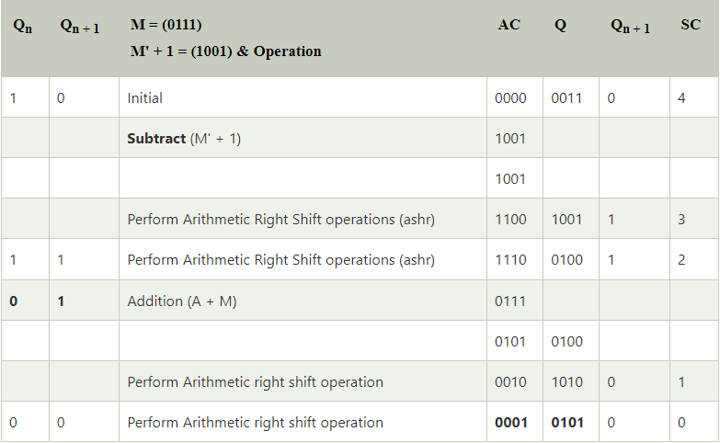

**Final Answer** = (0001 0101)2

= (21)10

**CODE**:

| #include<stdio.h> #include<stdlib.h> #include<string.h>   void rightShift();   int main() {  printf("\n");  printf("BOOTH's Algorithm\n");  printf("\n");  printf("Enter two numbers that are to be multiplied : ");//taking two numbers as inputs  int a,b;  scanf("%d %d",&a,&b);  int ap=a,bp=b;  if(ap<0) // Negetive values check  ap*=-1;  if(bp<0) bp*=-1;   if(bp>ap) //taking greater VALUE as multiplicand  {  ap=bp+ap-(bp=ap);   a=b+a-(b=a);  }  int t1=ap,t2=bp;  int ab[35]={};  int bb[35]={};  int i=0;  while(t1>0)  {  ab[i]=t1%2;  i++;  t1/=2;  }  ab[i]=0;  int j=0;  while(t2>0)  {  bb[j]=t2%2;  j++;  t2/=2;  }  while(j<=i) //equating bits to the previous(ab) binary number(ab will either be larger or equal to bb).  bb[j++]=0;  int nb=i+1; //nb is number of bits  i=0;j=0;  while(i<nb/2) //converting VALUES to binary  {  ab[i]=ab[nb-i-1]+ab[i]-(ab[nb-i-1]=ab[i]);  i++;  }  i=0;  while(i<nb/2) { bb[i]=bb[nb-i-1]+bb[i]-(bb[nb-i-1]=bb[i]); i++; } int x[35]={0}; int y[35]={0}; i=0; if(a>=0) //taking actual binary numbers  { //x is multiplicand and y is multiplier  while(i<nb)  x[i]=ab[i+++1];  }  else //2's complimant  {  while(i<nb) { if(ab[i]==0) x[i]=1; else x[i]=0; i++; } i=1; x[nb-i]++; while(x[nb-i]==2) { x[nb-i]=0; i++; x[nb-i]++; } } i=0; if(b>=0)  {  while(i<nb)  y[i]=bb[i+++1];  }  else //2's complimant  {  while(i<nb) { if(bb[i]==0) y[i]=1; else y[i]=0; i++; } i=1; y[nb-i]++; while(y[nb-i]==2) { y[nb-i]=0; i++; y[nb-i]++; } } printf("\n"); //output starts here printf("Multiplicand (Q) %d -> ",a);  i=0;  printf("Multiplicand (Q) -> ");  while(i<nb) printf("%d",x[i++]); printf("\nMultiplier (M) %d -> ",b);  i=0;  while(i<nb)  printf("%d",y[i++]);  printf("\n");  i=0;  int ym[35]={0}; //calculating -M  if(b<0)  {  while(i<nb)  ym[i]=bb[i+++1];  }  else  {  while(i<nb) { if(bb[i]==0) ym[i]=1; else ym[i]=0; i++; } i=1; ym[nb-i]++; while(ym[nb-i]==2) { ym[nb-i]=0; i++; ym[nb-i]++; } } printf("we use -(M) i.e. %d -> ",-b);  i=0;  while(i<nb)  printf("%d",ym[i++]);  printf("\n");  int q0=0;  int p[35]={0}; //p here is value that is stored in accumulator. initially set to zero.  int steps=nb;  printf("\n");  printf("n\t");   i=0;  while(i<nb)  {  if(i*2==nb || i*2==nb-1)  printf("A");  else  printf(" ");  i++;  }  printf(" ");  i=0;  while(i<nb)  {  if(i*2==nb || i*2==nb-1)  printf("Q\t");  else  printf(" ");  i++;  }  printf(" Q-1");  printf("\n");  j=0;    while(steps--) //counting down steps.  {  printf("%d ",j++);  i=0;  while(i<nb)  printf("%d",p[i++]);  printf(" ");  i=0;  while(i<nb)  printf("%d",x[i++]);  printf(" ");  printf("%d\n",q0);  if(x[nb-1]==0 && q0==0) //0-0 condition  {  q0=x[nb-1];  rightShift(p,x,nb);  }  else if(x[nb-1]==0 && q0==1) //0-1 condition  {  printf(" A + M ");  i=0;  while(i<nb)  printf("%d",y[i++]);  i=0;  while(i<nb)  {  p[nb-i-1]+=y[nb-i-1];  if(p[nb-i-1]==2)  {  p[nb-i-1]=0;  if(nb-i-1!=0)  p[nb-i-2]++;  }  if(p[nb-i-1]==3)  {  p[nb-i-1]=1;  if(nb-i-1!=0)  p[nb-i-2]++;  }  i++;  }  printf("\n ");  i=0;  while(i<nb)  printf("%d",p[i++]);  printf("\n");  q0=x[nb-1];  rightShift(p,x,nb);  }  else if(x[nb-1]==1 && q0==0) //1-0 condition  {  printf(" A - M ");  i=0;  while(i<nb)  printf("%d",ym[i++]);  i=0;  while(i<nb)  {  p[nb-i-1]+=ym[nb-i-1];  if(p[nb-i-1]==2)  {  p[nb-i-1]=0;  if(nb-i-1!=0)  p[nb-i-2]++;  }  if(p[nb-i-1]==3)  {  p[nb-i-1]=1;  if(nb-i-1!=0)  p[nb-i-2]++;  }  i++;  }  printf("\n ");  i=0;  while(i<nb)  printf("%d",p[i++]);  printf("\n");  q0=x[nb-1];  rightShift(p,x,nb);  }  else if(x[nb-1]==1 && q0==1) //1-1 condition  {  q0=x[nb-1];  rightShift(p,x,nb);  }  }  printf("%d ",j);  i=0;  while(i<nb)  printf("%d",p[i++]);  printf(" ");  i=0;  while(i<nb)  printf("%d",x[i++]);  printf(" ");  printf("%d\n",q0);  printf("\n");    printf("Final Product in signed binary number is : ");   i=0;  while(i<nb)  printf("%d",p[i++]);  i=0;  printf(" ");  while(i<nb)  printf("%d",x[i++]);  printf("\n\n");  return 0; }   void rightShift(int p[],int x[],int nb) {  int i=0;  while(nb-i-1)  {  x[nb-i-1]=x[nb-i-2];  i++;  }  x[0]=p[nb-1];  i=0;  while(nb-i-1)  {  p[nb-i-1]=p[nb-i-2];  i++;  } } |
| --- |

## **OUTPUT**:

